Event Listing Page
https://semo.dev.fastspot.com/components/preview/template-event-listing--default.html

Page Title
The page title is a required single line of text.

Events Filter
The Events Filter component gives the Visitor the ability to refine the default search results displayed on the page. The default search results are all Events sorted by:
- Event Start Date/Time (most recent first)
- Event Title (alphabetically)

Filters may be combined. Visitors filter by Category and by Month/Year. If a visitor selects a Month/Year, the results will show all events where the start date matches the Month/Year or the Month/Year falls between the start date and end date. The Events page can be pre-filtered by Category using the querystring.

Events Results
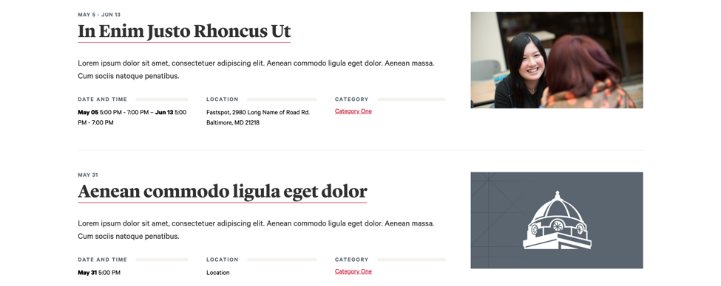
All data presented in the Events Results component will be pulled from the Event Detail pages:
- Title
- Link to Detail page
- Introduction
- Image
- Start
- End
- Location
- Category
Clicking the Category link will filter the results by that Category. In this event, any filter criteria for Month/Year will be reset.

Pagination
Up to 50 Events will be displayed in the search results. The pagination controls shown will be used to navigate the results if more than 50 are returned. A “No Results” state will be presented if results are not available based on

