Offices and Services Listing Page
https://semo.dev.fastspot.com/components/preview/template-offices-and-services.html

Page Title
The page title is a required single line of text.

Offices and Services Search and Filter
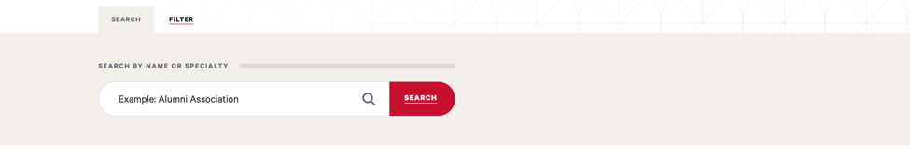
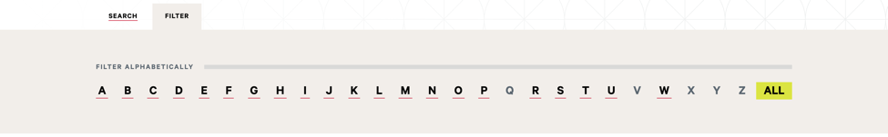
The Offices and Services Search and Filter component gives the Visitor the ability to refine the default search results displayed on the page. The default search results are all Offices and Services sorted alphabetically by Title. Searching and filtering are independent and cannot be combined.
Search tab:
- This tab is highlighted by default when the Visitor arrives at the page
- The search bar executes a free text search. Results will contain matches on Title.
Filter tab:
- Visitors may filter by the first letter of the Title. Letters without results will not have links.
- Text in other tabs will be ignored.

Offices and Services Block Data Definition
Offices & Services Data Type documented here
The full list of metadata for a Program is:
- Title – single line text. Required.
- Department – multi-select. Options are in Confluence. Required.
- Phone Numbers are a repeatable list (minimum 0) comprised of:
  - Phone Label – single line text. Required.
  - Phone Number – single line text. Required.
- Email Addresses are a repeatable list (minimum 0) comprised of:
  - Email Label – single line text. Required.
  - Email Address – single line text. Required.
- Locations are a repeatable list (minimum 0) comprised of:
  - Location Label – single line text. Required.
  - Location – WYSIWYG. Required.
- Hours are a repeatable list (minimum 0) comprised of:
  - Hours Label – single line text. Optional.
  - Hours – single line text. Required.
- Social Media are a repeatable list (minimum 0) comprised of:
  - LinkedIn URL – link chooser. Optional.
  - Twitter URL – link chooser. Optional.
  - Facebook URL – link chooser. Optional.
  - Instagram URL – link chooser. Optional.
  - YouTube URL – link chooser. Optional.
  - Video URL – link chooser. Optional.
  - Flickr URL – link chooser. Optional.
  - Reddit URL – link chooser. Optional.
  - Pinterest URL – link chooser. Optional.
- Detail Page Link – link chooser. Optional. This page will be built using the General Content page template.
- Display on Listing Page – Boolean. Required. This flag determines whether the block will be included in the resultset on the Offices and Services Listing page.

Offices and Services Results
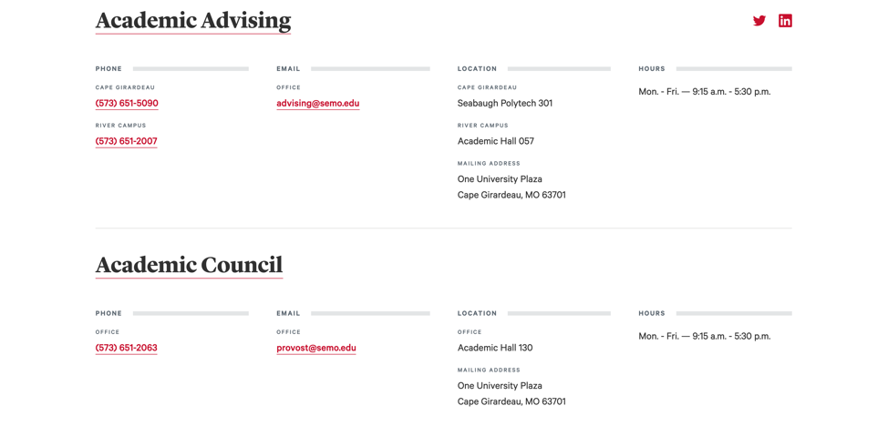
All data presented in the Offices and Services Results component will be pulled from the Offices and Services blocks:
- Title
- Detail Page Link
- Social Media
- Phone
- Email
- Location
- Hours

Pagination
Up to 10 Offices and Services will be displayed in the search results. The pagination controls shown will be used to navigate the results if more than 10 are returned. A “No Results” state will be presented if results are not available based on search or filter criteria.
s

